Online Cake Order WebApp

(Wireframe Documentation)

Homepage

I have divided Online Cake Order webapp into three main sections: Homepage, Login Screen and Dashboard.

* It contains Home, Menu, Services, About Us and Cart tab in Navigation Bar.
* It contains Hot Menu and Main menu recipes.

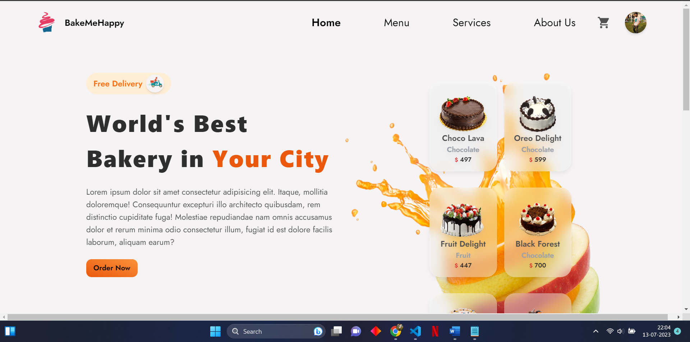

Dashboard contains Home, Orders, Items, Add New Item and Users available.

Login Screen

Login screen has two types of authentication methods: By login ID, password or By using Google Authentication.

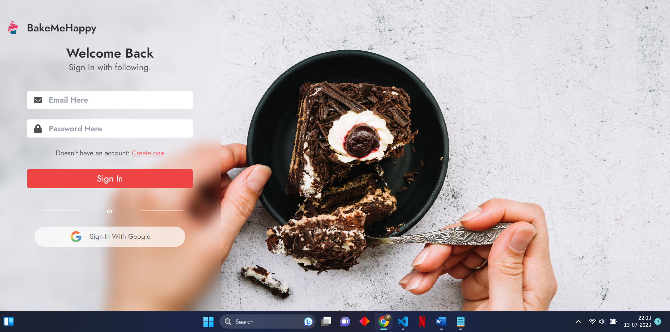

List of items (cakes) added with their description, filtering or insert, delete operation can also be performed.

Payments and Cart

Selected items can be checked out in cart section, quantity can be altered and further proceeded to payment section.

In the payment portal, payment details can be added and transaction details with receipt will be sent to both user and admin.

